|  |
| --- |
| PROJECT REPORT |



**OBJECT ORIENTED DESIGN AND PROGRAMMING**

**(2017/2018 SEM 2)**

**Members: Li Jin Quan(U1722463A)**

**Lee Jian Hao(U1721619C)**

 **Kok Jia Hui(U1721022E)**

**Chen Xing Yu(U1721205J)**

Contents

APPENDIX B 3

UML CLASS DIAGRAM 4

UML SEQUENCE DIAGRAM 5

Object oriented design concepts 6

Abstraction 7

Encapsulation / Information Hiding 7

Inheritance 8

Polymorphism 8

OO DESIGN CONSIDERATION 9

SRP – Single Responsibility Principle. 9

OCP – Open/Closed Principle. 9

LSP – Liskov Substitution Principle. 9

ISP – Interface Segregation Principle. 9

DIP – Dependency Inversion Principle. 9

TESTING 10

# APPENDIX B

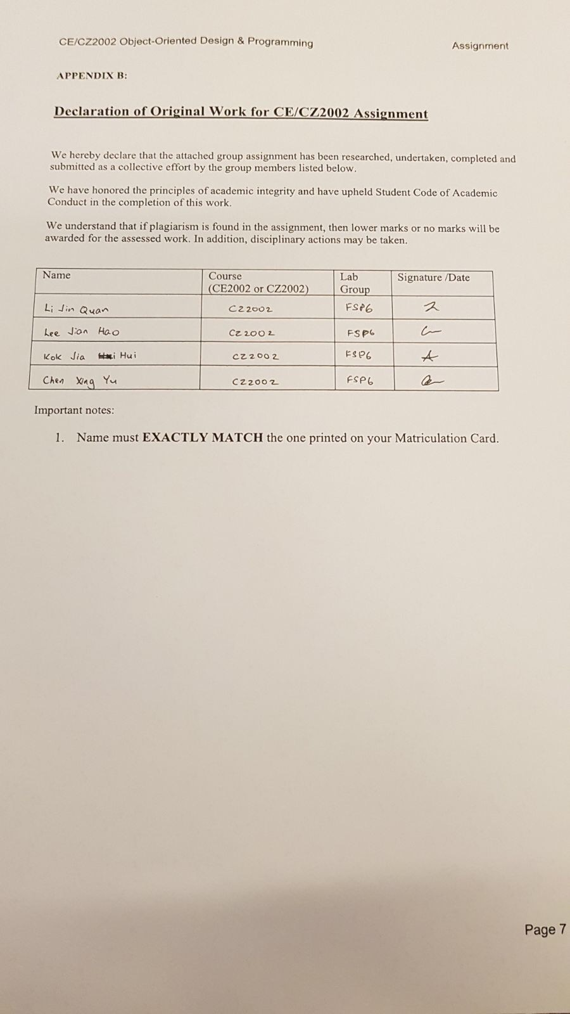

# UML CLASS DIAGRAM

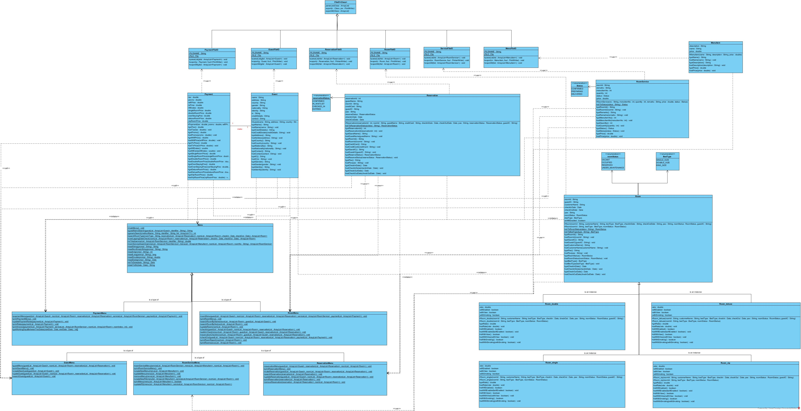

# UML SEQUENCE DIAGRAM

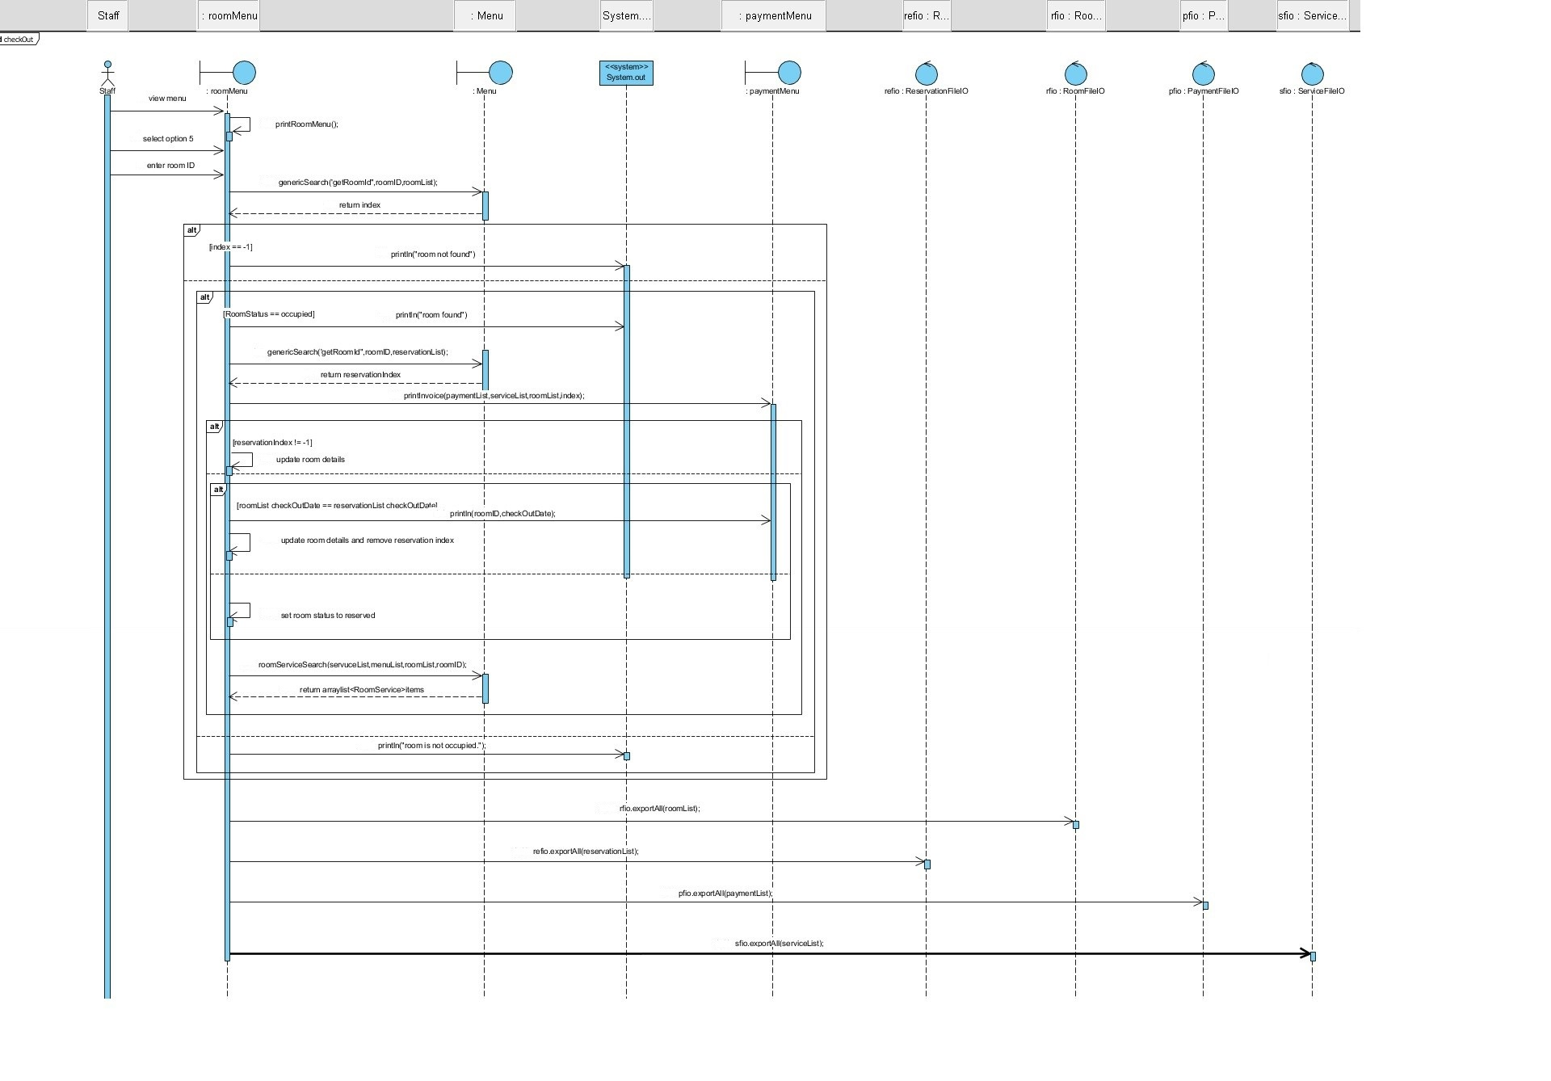

# Object oriented design concepts

**SDLC**

Software Development Lifecycle

Software Development Life Cycle is a well-defined, structured sequence of stages to develop the intended software product. Requirement and planning analysis allows the group members to evaluate various technical approaches that can be followed to implement the Hotel Reservation and Payment System successfully. A key component of a successful software is to have good design. It clearly defines all the architectural communication modules and data flow. It is a fundamental to Evolution stage where easy plug and play to the software allows extendibility, reusability and portability.

**Assumption made:**

* PaymentRate is a text file that must exist before program can run smoothly.
* Reservation and Maintenance must be planned and made at least 1 day in advance.
* Duration of stay must be at least 1 day.
* One Guest can make multiple reservations.
* Contact number of Guest is string as it can consist country code (e.g +65 for Singapore)
* User can only delete menu item from the menuList when there is no record of that menu item in serviceList.
* Each of the room have fixed attributes (e.g Wi-Fi, view, smoking), so customer who make a reservation should have already know the different specification of the room.
* Guest who check out early will still have to pay the full amount.
* Total price does not include view and smoking charges.
* Staff will physically check the Guest’s ID when they are checking in with reservation.

## Abstraction

In Object-Oriented(OO) technology, thinking in terms of objects perspective, it is the initial step to identify the essential characteristic of an object , include state, attributes and behaviors related to the object.

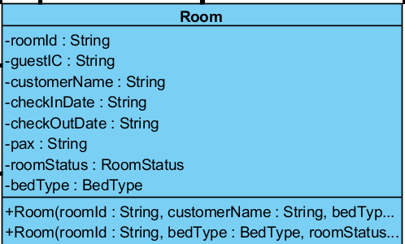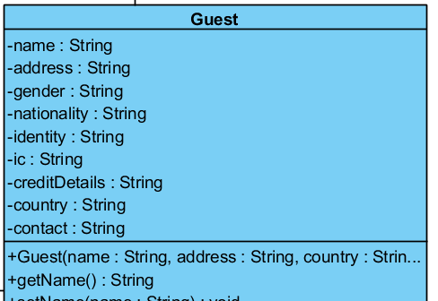

Figure : Room entity class

Figure 2:Guest entity class

## Encapsulation / Information Hiding

Encapsulation build a barrier to protect an objects private data. In good OO design, an object should only reveal the interface that other object needs to use. Information hiding is major part of encapsulation to avoid unnecessary modification to the data. For example,*Guest* class with private attributes such as name and address and modification are only available through getters and mutator methods. Robust classes are design with encapsulation in mind that is within control.

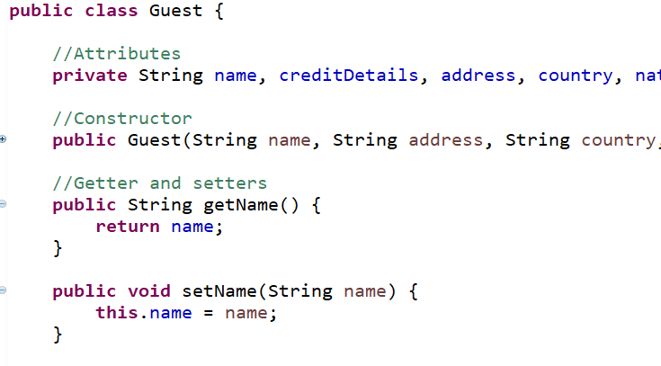

Figure 3: Guest entity class with code implementation

## 

## Inheritance

It is a power mechanism allow a class to inherit the attributes and methods of parent class. Some of the advantage is reduce in code duplication, extracting commonalities of various classes. For example abstract parent class of *FileIO,* inherit classes such as *GuestFileIO* and *ReservationFileIO* .

## Polymorphism

Polymorphism means many shapes. During runtime, actual object is being used, Polymorphism enable us to define any number of derived classes such as *GuestFileIO* and *ReservationFileIO* , different base class method such as parseList() and export() to allow polymorphism effect. No matter what kind of FileIO object is, correct method will return accordingly.

**Future SMS Proposal**

With this additional feature, guest who has made reservation will be sent a reminder message by SMS through our system. In order to implement this feature, we will importing Java library called “simplewire” into our current system. We will be creating a new class,”Sms.java” and there will be a static method that will make use of the existing function, genericSearch() , to retrieve the guest’s particulars. Also, we will set the subscriber setting that is provided by Simplewire’s resources as well as the message that is sent to the guest. Classes that required this function will only need to call this method. As a result, other classes will not be affected by this implementation.

# OO DESIGN CONSIDERATION

## SRP – Single Responsibility Principle.

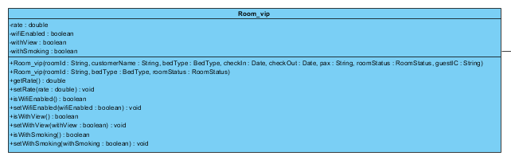

Room_vip will only be responsible for room that are used by VIP and the only reason that cause an alter will be due to the changes made to the attributes in this class. Therefore, there is only one responsibility and one reason for this class to change.

## OCP – Open/Closed Principle.

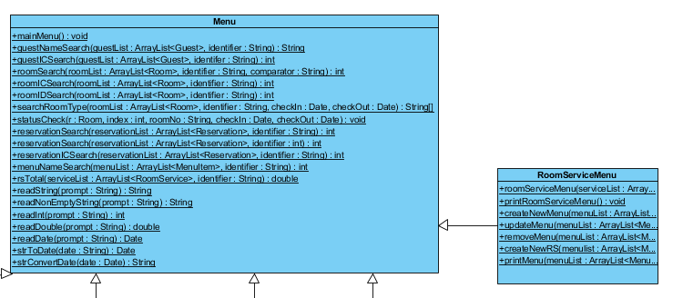

As seen in the class diagram, RoomServiceMenu inherit methods from Menu. RoomServiceMenu which is the subclass will override methods in Menu which is the superclass however this will not cause any changes to the methods in the superclass. Therefore, we can change what the modules do, without touching the source code of modules.

## LSP – Liskov Substitution Principle.

This is not applicable to the current system architecture.

## ISP – Interface Segregation Principle.

This is not applicable to the current system architecture.

## DIP – Dependency Inversion Principle.

This is not applicable to the current system architecture.

# TESTING

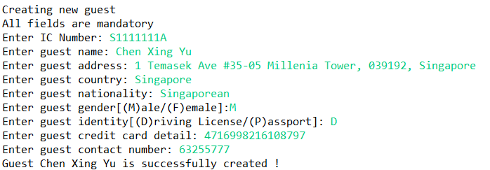

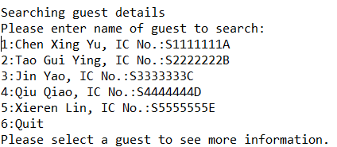

**Checking room details with guest name (but guest doesn’t occupied any room)**

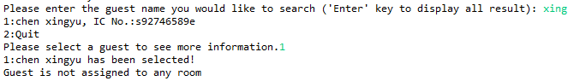

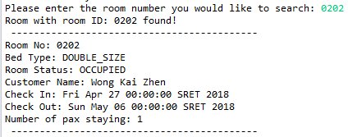**Checking room details with guest name Checking room details with room ID**

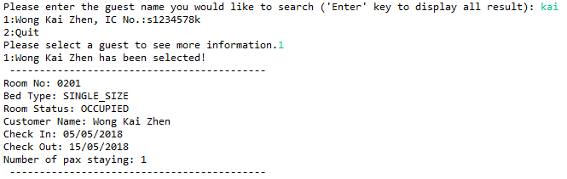

**Check In with Walk In method.**

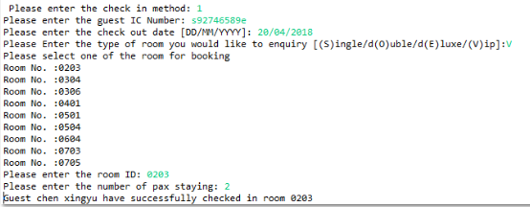

**Printing Room Report**

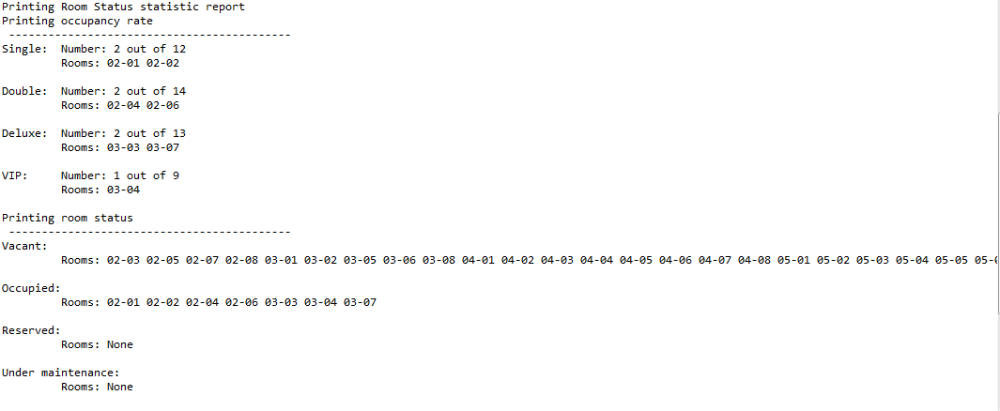

**Making Reservation**

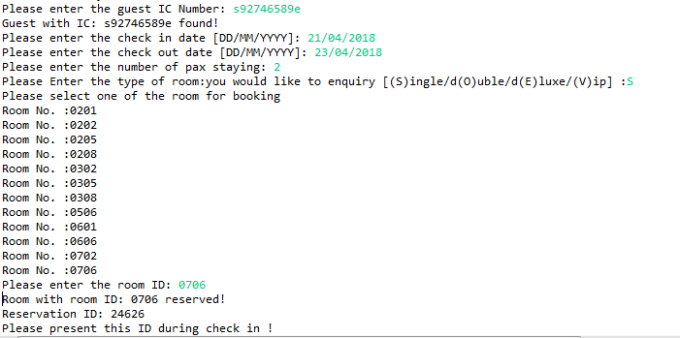

**Printing Reservation List Updating Reservation Status**

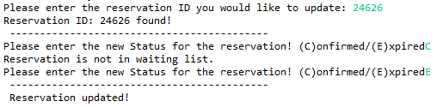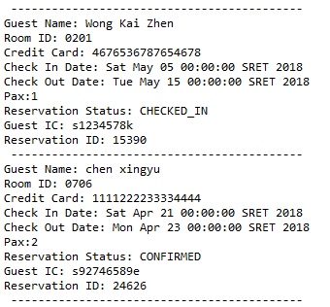

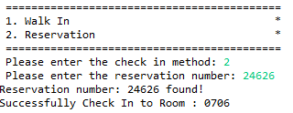**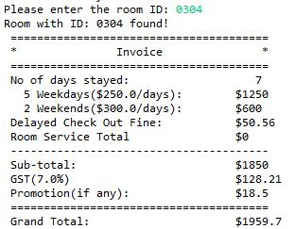Check In with Reservation Check Out**

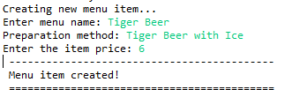**Creating new Room Service order**

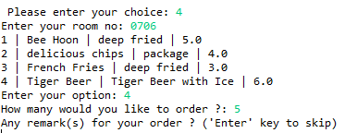

**Updating Menu Item Updating RoomService Status**

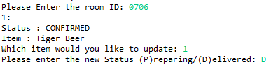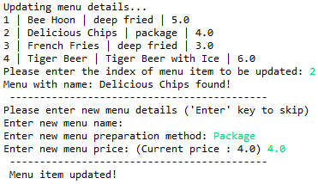

**Printing Payment rates**

